MEGHNAD SAHA INSTITUTE OF TECHNOLOGY

*Techno Complex, Madurdaha,Beside NRI Complex, Post-Uchhepota, Kolkata 700 150*

LABORATORY NOTE BOOK

MAKAUT ODD SEMESTER 2024



[MASTER OF COMPUTER APPLICATION]

[RELATIONAL DATABASE MANAGEMENT SYSTEM LAB (MCAN192)]

[RUPAK SARKAR]

ROLL NO: REGN. NO.:

STREAM: MCA SEMESTER: I (1ST)

YEAR: 1ST YearSESSION: 2024-2026



MAULANA ABUL KALAM AZAD UNIVERSITY OF TECHNOLOGY



MEGHNAD SAHA INSTITUTE OF TECHNOLOGY

*Techno Complex,. Madurdaha,Beside NRI Complex, Post-Uchhepota, Kolkata 700 150*

“LIST OF ASSIGNMENT/EXPERIMENT SUBMISSION DETAILS”

|  |  |  |  |  |  |
| --- | --- | --- | --- | --- | --- |
| **SL.**  **NO.** | **ASSIGNMENT / EXPERIMENT NAME** | **PLANNED DATE OF SUBMISSION** | **ACTUAL DATE OF SUBMISION** | **CHECKED BY** | **REMARKS (ANY DEVIATION REGARDING SUBMISSION DATES, CONTENT, FORMAT, ETC)** |
|  |  |  |  |  |  |
|  |  |  |  |  |  |
|  |  |  |  |  |  |
|  |  |  |  |  |  |
|  |  |  |  |  |  |
|  |  |  |  |  |  |
|  |  |  |  |  |  |
|  |  |  |  |  |  |
|  |  |  |  |  |  |
|  |  |  |  |  |  |

|  |
| --- |
| OBSERVATIONS / COMMENTS ON THE OVERALL PERFORMANCE: |

Signature in full with date Signature in full with date

**Faculty / Technical Assistant Lab Examiner**

**Q.1. Create a table called EMP with the following structure:  
EMPNO NUMBER(6),  
ENAME VARCHAR2(20),  
JOB VARCHAR2(10),  
DEPTNO NUMBER(3),  
SAL NUMBER(7,2).**

**Allow NULL for all columns except ENAME and JOB.**

Ans: To create the abovementioned table, we write the following command –

**SQL Query –** CREATE TABLE EMP(EMP_NO NUMBER(6), ENAME VARCHAR2(20) NOT NULL, JOB VARCHAR2(10) NOT NULL, DEPT_NO NUMBER(3), SAL NUMBER(7,2));

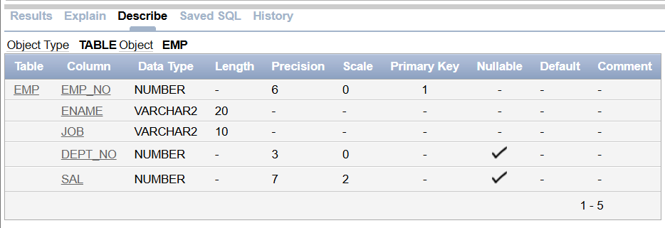

**Q.2. Add constraints to check, while entering the empno value (i.e., empno > 100).**

Ans: To add constraints to check while entering empno value, we need to write the following query.

**SQL Query –** ALTER TABLE EMP ADD CONSTRAINT CHK_EMPNO CHECK(EMP_NO>100);

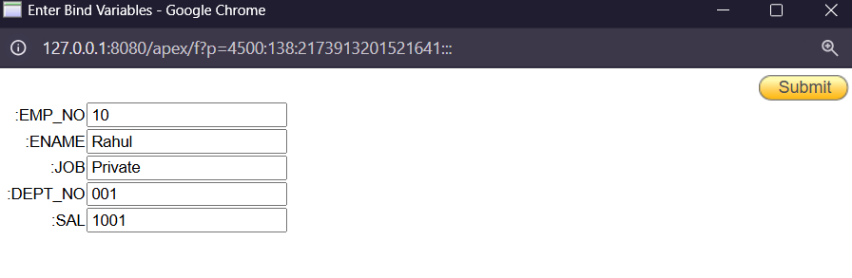

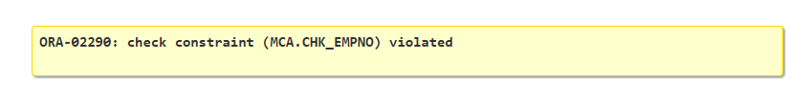

**Q.3. Define the field DEPTNO as unique.**

Ans: To define the DEPT_NO as Unique, we need to write the following query.

**SQL Query –** ALTER TABLE EMP ADD UNIQUE(DEPT_NO);

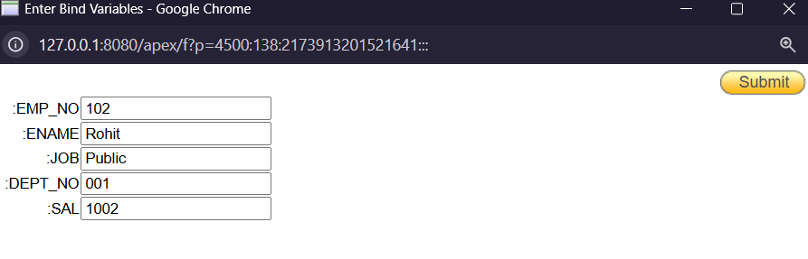

We, already have a Employee with a Dept_No=001.

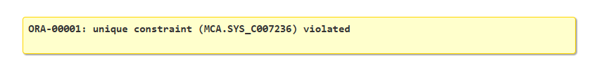

**Q.4. Create a primary key constraint for the table (EMPNO).**

Ans: To add a Primary Key to the EmpNo column, we need to write the following query.

**SQL Query –** ALTER TABLE EMP ADD PRIMARY KEY(EMP_NO);

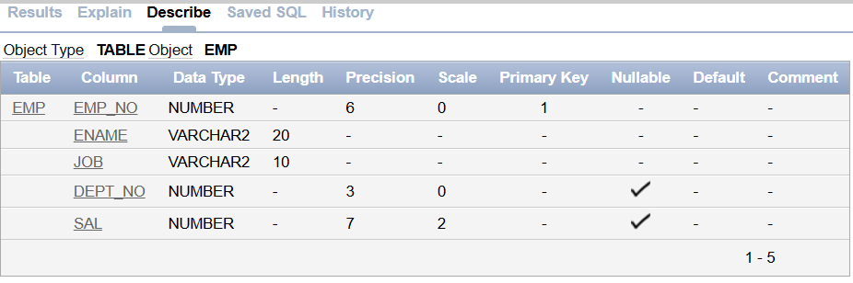

**Q.5. Write queries to implement and practice constraints.**

Ans:

**SQL Query –** ALTER TABLE EMP ADD CONSTRAINT CHK_SAL CHECK(SAL>1000); **[This query will create a check constraint for sal, this constraint means that during input of values we cannot input the value of Sal anything lesser than or equal to 1000.]**

**Implementation of Constraints from Ivan Bayross:**

**Table Name**: CLIENT_MASTER  
**Description**: Used to store client information.

|  |
| --- |
|  |
| **Column Name** | **Data Type** | **Size** | **Default** | **Attributes** |
| CLIENTNO | Varchar2 | 6 |  | Primary Key / first letter must start with 'C' |
| NAME | Varchar2 | 20 |  | Not Null |
| ADDRESS1 | Varchar2 | 30 |  | Not Null |
| ADDRESS2 | Varchar2 | 30 |  |  |
| CITY | Varchar2 | 20 |  |  |
| PINCODE | Varchar2 | 6 |  |  |
| STATE | Varchar2 | 10 |  |  |
| BALDUE | Number | 10,2 |  |  |

Ans: To create the above table we need to write the following query.

**SQL Query –** CREATE TABLE CLIENT_MASTER2(CLIENT_NO VARCHAR2(6) PRIMARY KEY CHECK(CLIENT_NO LIKE 'C%'), NAME VARCHAR2(20) NOT NULL, ADDRESS1 VARCHAR2(30), ADDRESS2 VARCHAR2(30), CITY VARCHAR2(15), PINCODE NUMBER(8), STATE VARCHAR2(15), BAL_DUE NUMBER(10,2));

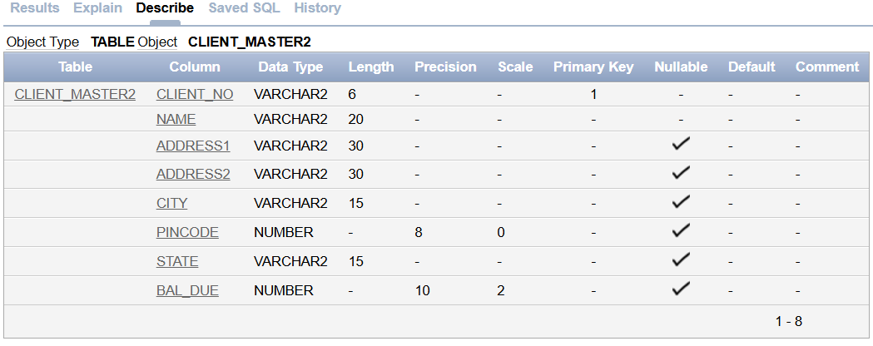

**Values of CLIENT_MASTER Table**:

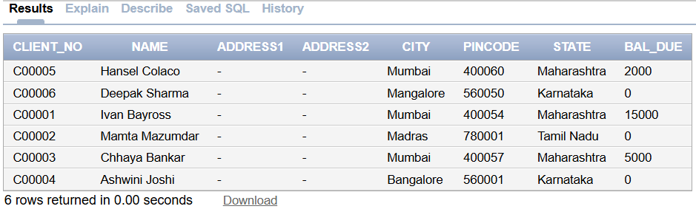

**Table Name**: PRODUCT_MASTER  
**Description**: Used to store product information.

|  |  |  |  |  |
| --- | --- | --- | --- | --- |
| **Column Name** | **Data Type** | **Size** | **Default** | **Attributes** |
| PRODUCTNO | Varchar2 | 6 |  | Primary Key / first letter must start with 'P' |
| DESCRIPTION | Varchar2 | 20 |  | Not Null |
| PROFITPERCENT | Number | 4,2 |  | Not Null |
| UNITMEASURE | Varchar2 | 2 |  | Not Null |
| QTYONHAND | Number | 8 |  | Not Null, Cannot be 0 |
| REORDERLEVEL | Number | 8 |  | Not Null, Cannot be 0 |
| SELPRICE | Number | 8,2 |  | Not Null |
| COSTPRICE | Number | 8,2 |  | Not Null |

Ans: To create the above table we need to write the following query.

**SQL Query –** CREATE TABLE PRODUCT_MASTER2(PRODUCT_NO VARCHAR2(6) PRIMARY KEY CHECK(PRODUCT_NO LIKE 'P%'), DESCRIPTION VARCHAR2(15) NOT NULL, PROFIT_PERCENT NUMBER(4,2) NOT NULL, UNIT_MEASURE VARCHAR2(10) NOT NULL, QTY_ON_HAND NUMBER(8) NOT NULL, REORDER_LVL NUMBER(8) NOT NULL, SELL_PRICE NUMBER(8,2) NOT NULL CHECK(SELL_PRICE <> 0), COST_PRICE NUMBER(8,2) NOT NULL CHECK(COST_PRICE <> 0));

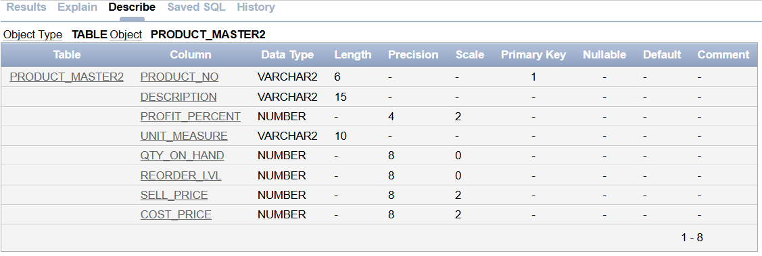

**Values of PRODUCT_MASTER Table**:

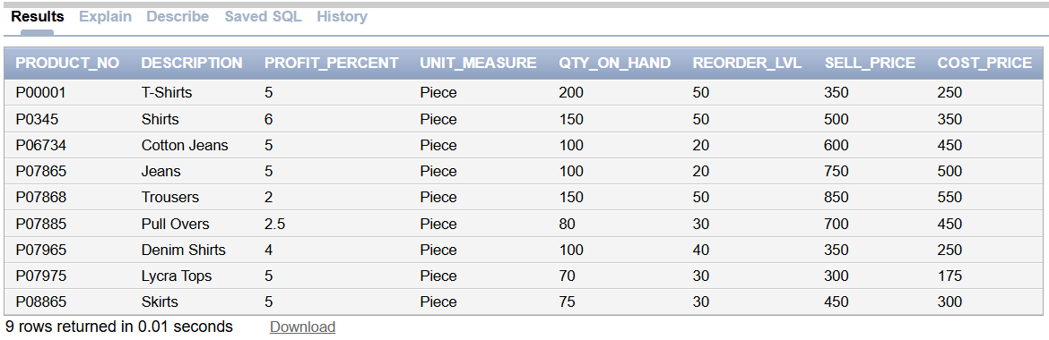

**Table Name**: SALESMAN_MASTER  
**Description**: Used to store salesman information working for the company.

|  |  |  |  |  |
| --- | --- | --- | --- | --- |
| **Column Name** | **Data Type** | **Size** | **Default** | **Attributes** |
| SALESMANNO | Varchar2 | 6 |  | Primary Key / first letter must start with 'S' |
| SALESMANNAME | Varchar2 | 20 |  | Not Null |
| ADDRESS1 | Varchar2 | 30 |  | Not Null |
| ADDRESS2 | Varchar2 | 30 |  |  |
| CITY | Varchar2 | 20 |  |  |
| PINCODE | Varchar2 | 6 |  | Not Null |
| STATE | Varchar2 | 20 |  | Not Null |
| SALARY | Number | 6,2 |  | Not Null |
| TGTTOGET | Number | 6,2 |  | Cannot be 0 |
| YTDSALES | Number | 6,2 |  | Not Null |
| REMARKS | Varchar2 | 60 |  |  |

Ans: To create the above table we need to write the following query.

**SQL Query –** CREATE TABLE SALESMAN_MASTER2(SALESMAN_NO VARCHAR2(6) PRIMARY KEY CHECK(SALESMAN_NO LIKE 'S%'), SALESMAN_NAME VARCHAR2(20) NOT NULL, ADDRESS1 VARCHAR2(30) NOT NULL, ADDRESS2 VARCHAR2(30), CITY VARCHAR2(20), PINCODE NUMBER(8), STATE VARCHAR2(20), SAL_AMT NUMBER(8,2) NOT NULL CHECK(SAL_AMT <> 0), TGT_TO_GET NUMBER(6,2) NOT NULL CHECK(TGT_TO_GET <> 0), YTD_SALES NUMBER(6,2) NOT NULL, REMARKS VARCHAR2(60));

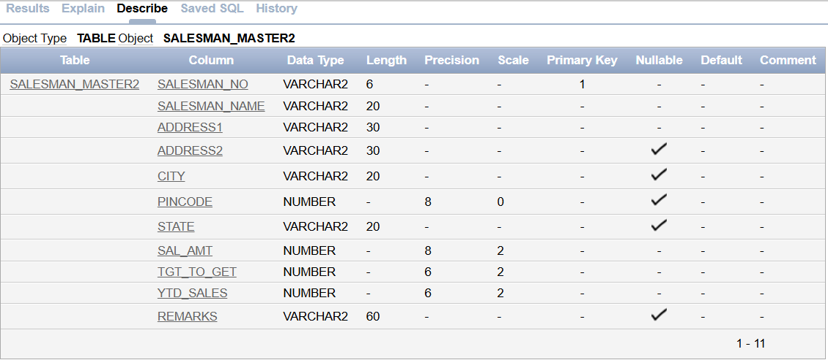

**Values of SALESMAN_MASTER Table**:

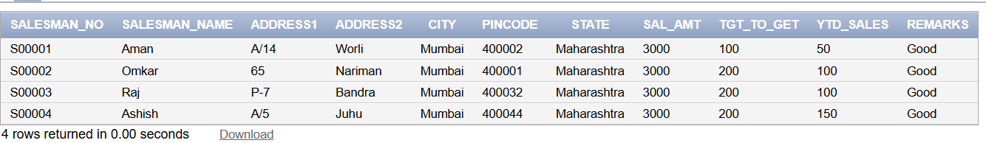

**Table Name**: SALES_ORDER  
**Description**: Used to store client’s orders.

|  |  |  |  |  |
| --- | --- | --- | --- | --- |
| **Column Name** | **Data Type** | **Size** | **Default** | **Attributes** |
| ORDERNO | Varchar2 | 6 |  | Primary Key / first letter must start with 'O' |
| CLIENTNO | Varchar2 | 6 |  | Foreign Key references ClientNo of Client_Master table |
| ORDERDATE | Date |  |  | Not Null |
| DELYADDR | Varchar2 | 25 |  | Not Null |
| SALESMANNO | Varchar2 | 6 |  | Foreign Key references SalesmanNo of Salesman_Master table |
| DELYTYPE | Char | 1 | F | Delivery: part (P) / full (F) |
| BILLYN | Char | 1 | F |  |
| DELYDATE | Date |  |  | Cannot be less than Order Date |
| ORDERSTATUS | Varchar2 | 10 |  | Values ('In Process', 'Fulfilled', 'BackOrder', 'Cancelled') |

Ans: To create the above table we need to write the following query.

**SQL Query –** CREATE TABLE SALES_ORDER2(ORDER_NO VARCHAR2(6) PRIMARY KEY CHECK(ORDER_NO LIKE 'O%'), CLIENT_NO VARCHAR2(6), FOREIGN KEY(CLIENT_NO) REFERENCES CLIENT_MASTER2, ORDER_DATE DATE NOT NULL, DELYA_ADDR VARCHAR2(25), SALESMAN_NO VARCHAR2(6), FOREIGN KEY(SALESMAN_NO) REFERENCES SALESMAN_MASTER2, DELY_TYPE CHAR(1) DEFAULT 'F' CHECK(DELY_TYPE IN('P','F')), BILL_YN CHAR(1), DELY_DATE DATE, ORDER_STATUS VARCHAR2(10) CHECK(ORDER_STATUS IN('In Process', 'Fulfilled', 'BackOrder', 'Cancelled')), CONSTRAINT CHK_DELY_DATE CHECK (DELY_DATE >= ORDER_DATE));

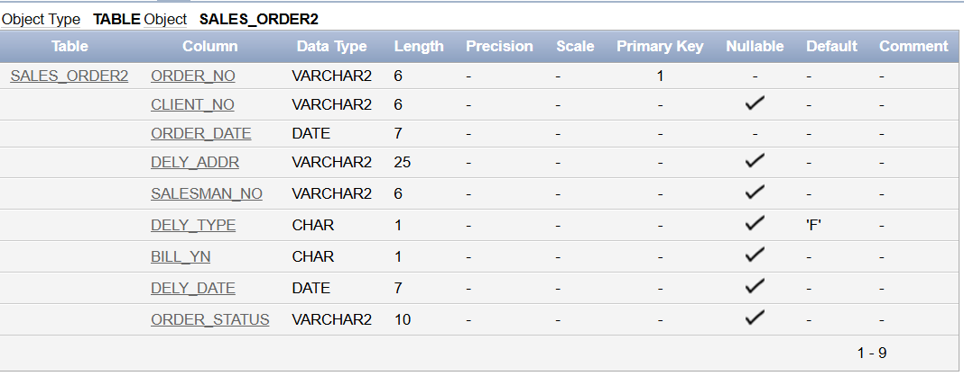

**Values of SALES_ORDER Table**:

**SQL Query –** INSERT INTO SALES_ORDER2(ORDER_NO, CLIENT_NO, ORDER_DATE, SALESMAN_NO, DELY_TYPE, BILL_YN, DELY_DATE, ORDER_STATUS) VALUES (:ORDER_NO, :CLIENT_NO, TO_DATE(:ORDER_DATE, 'DD-MM-YYYY'), :SALESMAN_NO, :DELY_TYPE, :BILL_YN, TO_DATE(:DELY_DATE, 'DD-MM-YYYY'), :ORDER_STATUS);

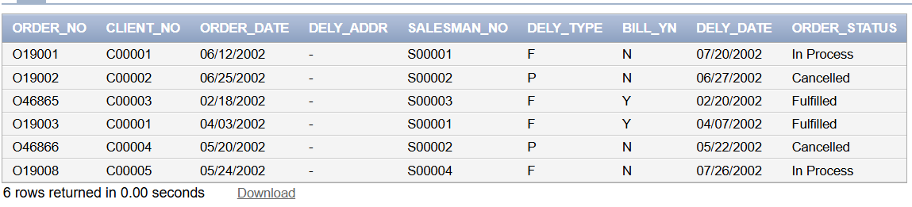

**Table Name**: SALES_ORDER_DETAILS  
**Description**: Used to store client’s orders with details of each product ordered.

|  |  |  |  |  |
| --- | --- | --- | --- | --- |
| **Column Name** | **Data Type** | **Size** | **Default** | **Attributes** |
| ORDERNO | Varchar2 | 6 |  | Foreign Key references OrderNo of Sales_Order table |
| PRODUCTNO | Varchar2 | 6 |  | Foreign Key references ProductNo of Product_Master table |
| QTYORDERED | Number | 8 |  |  |
| QTYDISP | Number | 8 |  |  |
| PRODUCTRATE | Number | 10,2 |  |  |

Ans: To create the above table we need to write the following query.

**SQL Query –** CREATE TABLE SALES_ORDER_DETAILS(ORDER_NO VARCHAR2(6), FOREIGN KEY(ORDER_NO) REFERENCES SALES_ORDER2, PRODUCT_NO VARCHAR2(6), FOREIGN KEY(PRODUCT_NO) REFERENCES PRODUCT_MASTER2, QTY_ORDERED NUMBER(8), QTY_DISP NUMBER(8), PRODUCT_RATE NUMBER(10,2));

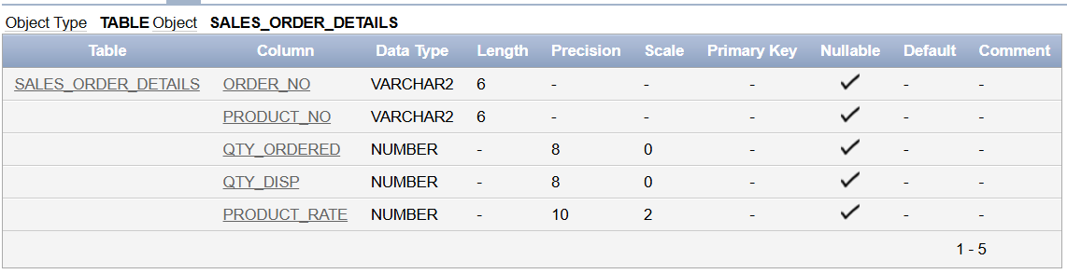

**Values of SALES_ORDER_DETAILS Table**:

**SQL Query –** INSERT INTO SALES_ORDER_DETAILS(ORDER_NO, PRODUCT_NO, QTY_ORDERED, QTY_DISP, PRODUCT_RATE) VALUES (:ORDER_NO, :PRODUCT_NO, :QTY_ORDERED, :QTY_DISP, :PRODUCT_RATE);

